**REACT**

**Hands On – 3**

Create a react app for Student Management Portal named scorecalculatorapp and create a function component named “CalculateScore” which will accept Name, School, Total and goal in order to calculate the average score of a student and display the same.

**Steps:**

1. Install Create-react-app by running the following command
2. To create a React Application with the name of “myfirstreact”, type the following command:
3. Open the folder of StudentApp in Visual Studio Code
4. Open the Src Folder and create CalculateScore.js
5. Remove the current content of “App.js”
6. Replace it with the following:

App.js

import React from 'react';

import CalculateScore from './Components/CalculateScore';

function App() {

  return (

    <div className="App">

      <CalculateScore name="Abinaya" school="Taekook Public School" total={560} goal={600} />

    </div>

  );

}

export default App;

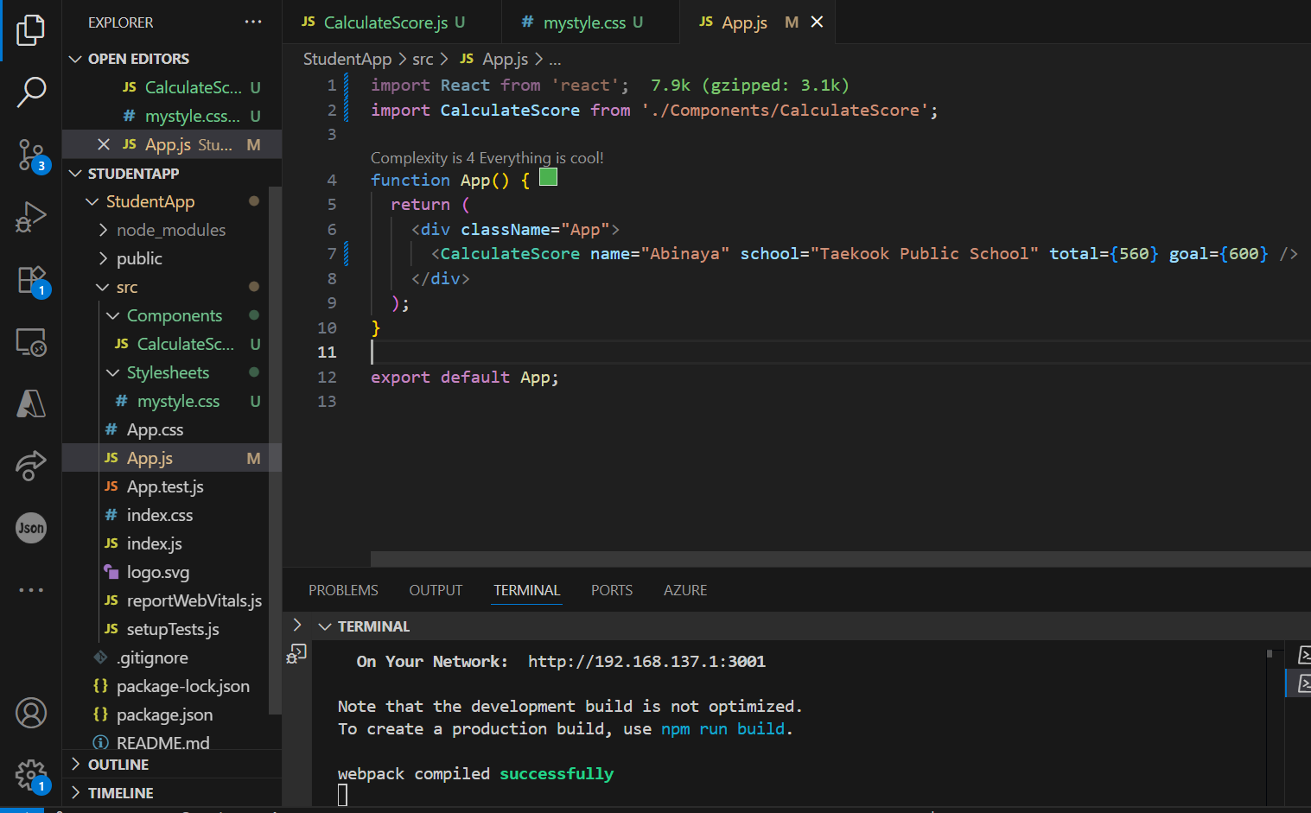

CalculateScore.js

import React from 'react';

import '../Stylesheets/mystyle.css';

function CalculateScore(props) {

  const { name, school, total, goal } = props;

  const percentage = ((total / goal) * 100).toFixed(2);

  return (

    <div className="student-container">

      <h1 className="title">Student Details:</h1>

      <p><span className="label name-label">Name:</span> <span className="value name-value">{name}</span></p>

      <p><span className="label school-label">School:</span> <span className="value school-value">{school}</span></p>

      <p><span className="label total-label">Total:</span> <span className="value">{total} Marks</span></p>

      <p><span className="label score-label">Score:</span> <span className="value score-value">{percentage}%</span></p>

    </div>

  );

}

export default CalculateScore;

**Output:**

